Subscribe to DeepL Pro to edit this document.
Visit www.DeepL.com/pro for more information.

catalogs
1 Products 1
1.1 HackRF Hardware Specifications 1
1.1.1 HackRF transmit power 1
1.1.2 HackRF receive power 2
1.2 HackRF Hardware Interface 2
2 Windows Basic Usage Tutorial 3
2.1 Driver Installation 3
2.2 sdrsharp receives FM broadcasts 4
3 Basic Ubuntu Tutorials 5
3.1 Ubuntu System Installation 5
3.2 SDR Related Software Installation 5
3.3 HackRF Basic Test Methodology 5

Products
HackRF One is a software radio platform with open source hardware and software that transmits and receives signals in the range of 1MHz-6GHz, and can be used to design, implement and verify wireless communication technologies.

HackRF Hardware Specifications
Operating frequency band: 1MHz-6GHz
Duplex mode: half-duplex send/receive
RF bandwidth: 20MHz
Sampling rate: 2 Msps~20 Msps
Power supply/transfer interface: USB2.0
Wireless RF transceiver MAX2837 (2.3~2.7 GHz transceiver)
Mixer RFFC5072 (30MHz~6GHz)
Processor LPC43xx ARM Cortex-M4
Complex Programmable Logic Device CPLD CoolRunner-II

HackRF transmit power
According to the wiki information on the HackRF github, the transmit power of the HackRF varies slightly at different frequencies.
1, 1 MHz to 10 MHz
5 dBm to 15 dBm, which typically rises with frequency.
2, 10 MHz to 2150 MHz
5 dBm to 15 dBm, usually decreasing as the frequency increases.
3. 2150 MHz to 2750 MHz
13 dBm to 15 dBm
4, 2750 MHz to 4000 MHz
0 dBm to 5 dBm, usually decreasing as the frequency increases.
5. 4000 MHz to 6000 MHz
-10 dBm to 0 dBm, usually decreasing as frequency increases.
In most frequency ranges up to 4GHz, the maximum TX power is between 0 and 10dBm. The best performing frequency range is 2150mhz to 2750mhz.
Overall, the output power of the HackRF is sufficient for wireless experiments at close range, or you can increase the output power by adding a power amplifier to suit your needs. If you use a power amplifier, it is recommended that you also prevent strong interference to other frequency bands by using an external bandpass filter.
Before you do the experiment, you'd better fully understand the relevant national regulations on wireless communication frequency bands and transmit power, and know whether your operation is in line with the regulations on radio signal transmission. All in all, it is your responsibility to use your HackRF One in a legally regulated manner.

HackRF Receive Power
The maximum received power supported by the HackRF is -5dbm, exceeding -5dbm can cause devastating physical hardware damage to the HackRF. If you are feeding a signal generator or other device into the HackRF, it is best to add a signal attenuator for safety reasons.

HackRF Hardware Interface
The buttons and SMA interface functions are as follows:
keystrokes | Functional meaning
reset button | Reboot the HackRF to reset it. Pressing the reset button does the same thing as unplugging the USB cable that connects the HackRF to the computer and then plugging it back in.
Engineering Mode Key | (1) Force HackRF into DFU mode. When you need to brush the hackrf_one_usb.dfu firmware of HackRF, you need to press and hold the Engineering Mode button (i.e. DFU button) without letting go of it, and at the same time, plug the USB cable that has been connected to the computer (Note: Windows or Ubuntu computer needs to have the driver of HackRF installed) into the Micro-USB port, then the LED light on the development board of HackRF labeled as 3V3 LED on the HackRF development board will light up, at this time, it means that the board has entered the DFU mode.  (2) Next, you can use the dfu-util --device 1fc9:000c --alt 0 --download hackrf_one_usb.dfu command to brush HackRF's hackrf_one_usb.dfu firmware. All the development boards in this store before shipment, have been brushed with this firmware and other related firmware (hackrf_one_usb.bin and hackrf_cpld_default.xsvf), for the novice can not care about these brushes things, get it, directly in the computer after the installation of the driver, plug in the data cable can be used.
Antenna, Transmit/Receive | The antenna connector is an SMA female connector, and the antenna connector needs to be an SMA internal screw with internal pins.
Micro-USB | Data cable port, Micro-USB port.
Clock (out) | The HackRF development board outputs a 10MHz clock signal on the clock (out) SMA interface, which is a 10MHz, square wave with a voltage value of 0V-3V.
Clock (in) | You can input a 10MHz square wave of 0V-3V to the HackRF on the clock (in) SMA connector, and note that the input square wave voltage should not exceed 3.3V and should not be lower than 0V. You can also connect the signal from the clock (out) of one HackRF with a connecting cable to the clock (in) of another HackRF, and for the cascading of the clocks between two HackRFs, see the following paper, Synchronization of Low-Cost Open Source SDRs for Navigation Applications. See the following paper, Synchronization of Low-Cost Open Source SDRs for Navigation Applications.

The meanings of the LED indicators are as follows:
LED light | Functional meaning
3v3 LED  1v8 LED  RF LED | These three LEDs are used to indicate whether the power supply to the development board is normal or not, if the power supply to the development board is normal, all three lights should be on.
USB LED | The USB light is used to indicate whether the USB connection between the development board and the computer is normal or not, if your computer driver installation is normal, the USB light should be on when you only connect the HackRF to the computer via the USB cable. However, it should be noted that when your HackRF+Portapack (portapack is plugged into the HackRF), the USB light will not be on when you connect the development board to the computer via USB.
RX LED | This lamp lights when the HackRF is receiving a signal.
TX LED | This lamp lights when the HackRF is transmitting a signal.

Basic Windows Tutorial
The basic use of HackRF One on Windows means installing the driver for HackRF One, receiving FM broadcasts with the sdrsharp software, and transmitting signals with hackrf_transfer.exe.

Driver Installation
The driver for HackRF One on Windows is Zadig.exe.We can install just this one driver and we can use HackRF One on Windows.
Download and install Zadig driver, HackRF with a USB cable into the computer, the computer will prompt the USB can not be recognized, so you need to download and install the Zadig driver, download link is: http://zadig.akeo.ie/
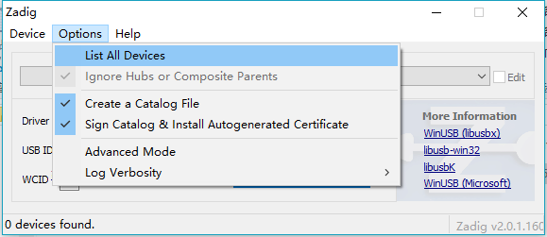
Select "HackRF One" in the device list and click Install driver.
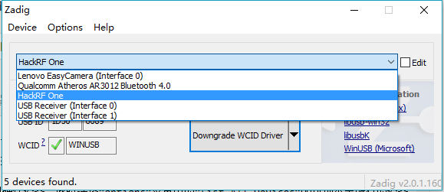
After the driver is successfully installed, as shown below.
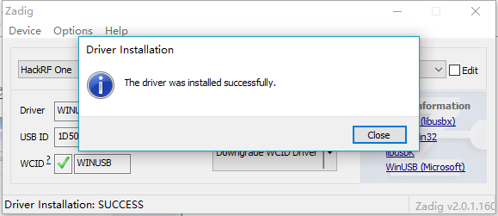

sdrsharp receives FM broadcasts
Download and install sdrsharp (also known as SDR #) at the following link: http://airspy.com/download/
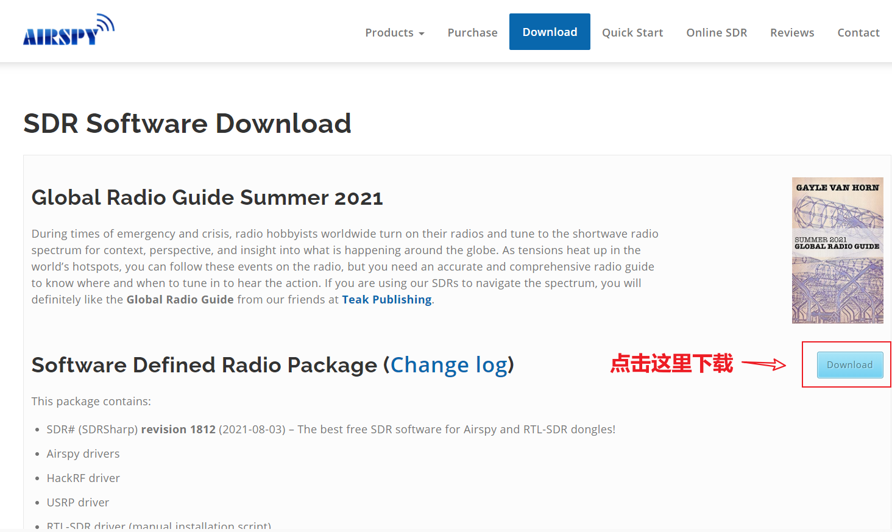
After unzipping, click Run SDRSharp.exe to run SDR#.
Click the Setup button ( ), select Device as HackRF One, sample rate as 20 MSPS, LNA Gain and VGA Gain can be adjusted by yourself. If your LNA Gain and VGA Gain can not be adjusted at this time, click Close first, then click the Start button on the left side of the Setup button, i.e., start to receive signals, and then click the Setup button again, then these two gains can be adjusted. Select Radio as WFM.
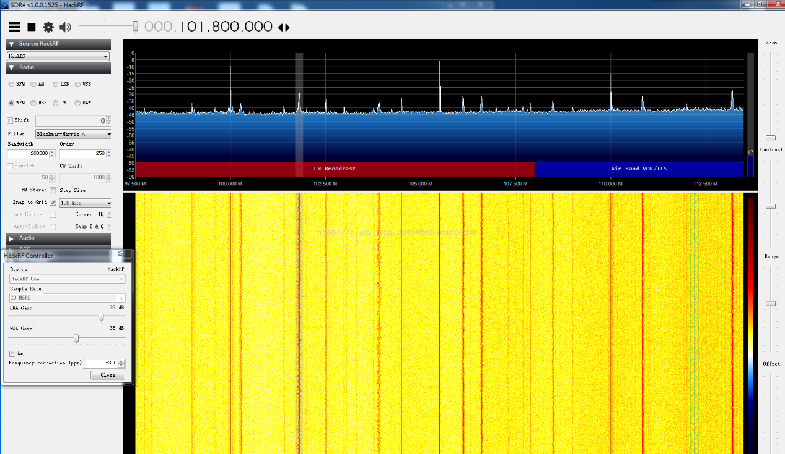

Ubuntu Basic Tutorial

Ubuntu System Installation
There are many tutorials on the Ubuntu web, see, the
https://www.cnblogs.com/springsnow/p/12188891.html
https://jingyan.baidu.com/article/3c343ff7d596480d3779630f.html
https://www.jianshu.com/p/54d9a3a695cc

SDR-related software installation
For installing SDR related software under Ubuntu system, you can refer to the CSDN blog [Ubuntu HackRF One, GNU Radio, Gqrx related environment building].
https://blog.csdn.net/OpenSourceSDR/article/details/81143661
For newbies, or if you don't have any special requirements for the version of the software, it is highly recommended that you use the apt-get install method.

HackRF Basic Test Methods
After installing the HackRF software, enter the command, hackrf_info, in the terminal to view the information about hackrf. If hackrf_info returns normal information, then you can use the gqrx software to test the hackrf signal reception function. Specifically, you can see the CSDN blog [HackRF and Gqrx to listen to FM radio].
https://blog.csdn.net/OpenSourceSDR/article/details/51911220

